Arizona State University
Institutional Animal Care and Use Committee
STANDARD INSTITUTIONAL GUIDELINE

INTRANASAL AND ORAL ADMINISTRATION IN RODENTS

Purpose
While antibody production is typically induced via intramuscular, subcutaneous, or intraperitoneal injections of antigen, there is an increased interest in less invasive, less complex, and more clinically relevant means of delivering antigens and vaccines.

Delivery of Antigen or Vaccine
All procedures should be done using personal protective equipment and a biosafety cabinet if required for the room housing the animals.

Intranasal
Mouse
- The mouse is restrained by holding it by the scruff in dorsal recumbancy.
- 5-10 microliters (µL) of material is then delivered by the individual restraining the mouse or a second individual into each nostril using a mechanical pipette. The mouse is carefully monitored for signs of distress (excessive struggling, mucus membrane color changes, ventilatory changes) while the procedure is being performed and between nostril injections.
- If the animal shows any signs of distress, it is released from restraint and monitored. The veterinary team should be called if the animal does not immediately return to a normal state.
- The mouse is then returned to its cage and observed for any signs of distress that are immediately apparent.
- Delivery of material is conducted at intervals and durations as described in the IACUC-approved protocol.

Rat
- The rat is restrained by wrapping it in a towel and holding the temporomandibular joint gently to control head movement.
- 10-20 microliters (µL) of material is then delivered by the individual restraining the rat or a second individual into each nostril using a mechanical pipette. The animal is carefully monitored for signs of distress (excessive struggling, mucus membrane color changes, ventilatory changes) while the procedure is being performed and between nostril injections.
- If the animal shows any signs of distress, it is released from restraint and monitor. The veterinary team should be called if the animal does not immediately return to a normal state.
- The rat is then returned to its cage and observed for any signs of distress that are immediately apparent.
- Delivery of material is conducted at intervals and durations as described in the IACUC-approved protocol.

Oral
- The mouse is restrained in a vertical (i.e., head up) position by holding the mouse by the scruff. It is important that the mouse’s head and neck are positioned straight in line with the spine (Figures b, c).
- If stomach neutralization is required before delivery, the mouse is first administered 50-100ul of sodium bicarbonate.
- If gavaging the material directly into the stomach, an appropriately sized gavage needle is attached to 1ml syringe. Needle size for a mouse should be 20-22g with the length depending on the size of the mouse. A proper measurement is made by measuring from the corner of the mouth to just past the rib cage (Figure a). To help ensure that the needle is correctly inserted into the stomach, a mark can be made on the needle with a Sharpie if the hub is not at the corner of the mouth. The gavage needle is gently and slowly passed down the esophagus until the mark on the needle reaches the mouse’s nose. If resistance is noted while being inserted, the gavage needle is retracted and repositioned. Volume should not exceed 150ul.
- Once the needle is properly positioned, the material is slowly administered while the mouse is monitored for signs of distress (as described above) or the emergence of fluid from the nostrils. The needle can then be carefully removed and the mouse returned to its cage.
- If administering the material in a pipette, 5-25µl is slowly dripped into the mouse’s mouth, allowing time for the animal to swallow each drop. The animal should be held for approximately 20 additional seconds to ensure that the material is consumed.

- Delivery of material is conducted at intervals and durations as described in the IACUC protocol.
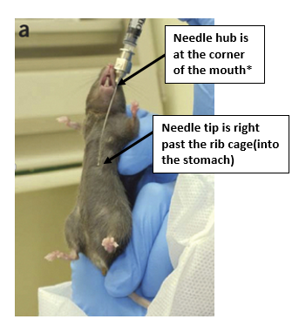
* The needle size here is 20-22g x 1.5 inch
